You can find square roots and cube roots quickly using Newton's method. It requires division. Newton's method is an iterative algorithm that quickly finds roots of a function.
Given an initial estimate x0 for a root of f, draw the tangent line to the graph y=f(x) at the point (x0,f(x0)) and determine where the tangent crosses the x-axis. That point, x1, called the subtangent, is given by the formula
x1=x0−f(x0)f′(x)0
Repeat to get better estimates of the root.
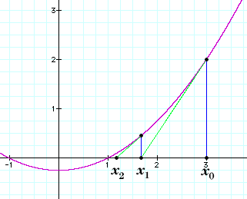
Suppose you want to find the nth root of a (where a is positive in the case that n is even). Let f(x)=x^n−a. You want to find a root of f.
The derivative of f is f′(x)=nx^n−1. The iterative formula is
x1=x0−xn0−anxn−10
When n=2, this simplifies to
x1=12(x0+a/x0)
which says take the average of your first guess and a divided by your first guess.
When n=3, this simplifies to
x1=23x0+13a/x20
You initial value x0 doesn't matter too much, but a good start will save you one or two steps in your computation. x0=a/n is a reasonable start.
After you get going with Newton's method, each iteration doubles the number of digits of accuracy.

